Project Design Phase
Problem – Solution Fit

Date | 15 February 2026
Team ID | LTVIP2026TMIDS54443
Project Name | Exploratory-Analysis-Of-RainFall-Data-In-India-For-Agriculture
Maximum Marks | 2 Marks

Problem – Solution Fit Template:
Indian farmers heavily depend on rainfall for agriculture, but due to climate change and unpredictable weather patterns, rainfall has become irregular and unreliable. Inaccurate weather reports and sudden changes in temperature often lead to poor crop growth, overwatering or drought conditions, and financial losses for farmers. To address this issue, a reliable rainfall prediction and climate monitoring system can be developed using historical weather data and advanced analysis techniques. This solution would help farmers plan irrigation schedules, manage water resources effectively, make informed farming decisions, reduce crop loss, and ultimately improve productivity and income.
Purpose:
- Who the target customers are
- What problems or pains they are facing
- What are the root causes of those problems
- How customers behave and respond
- What limitations they have
- What existing solutions are available
- And how our proposed solution effectively solves their problem

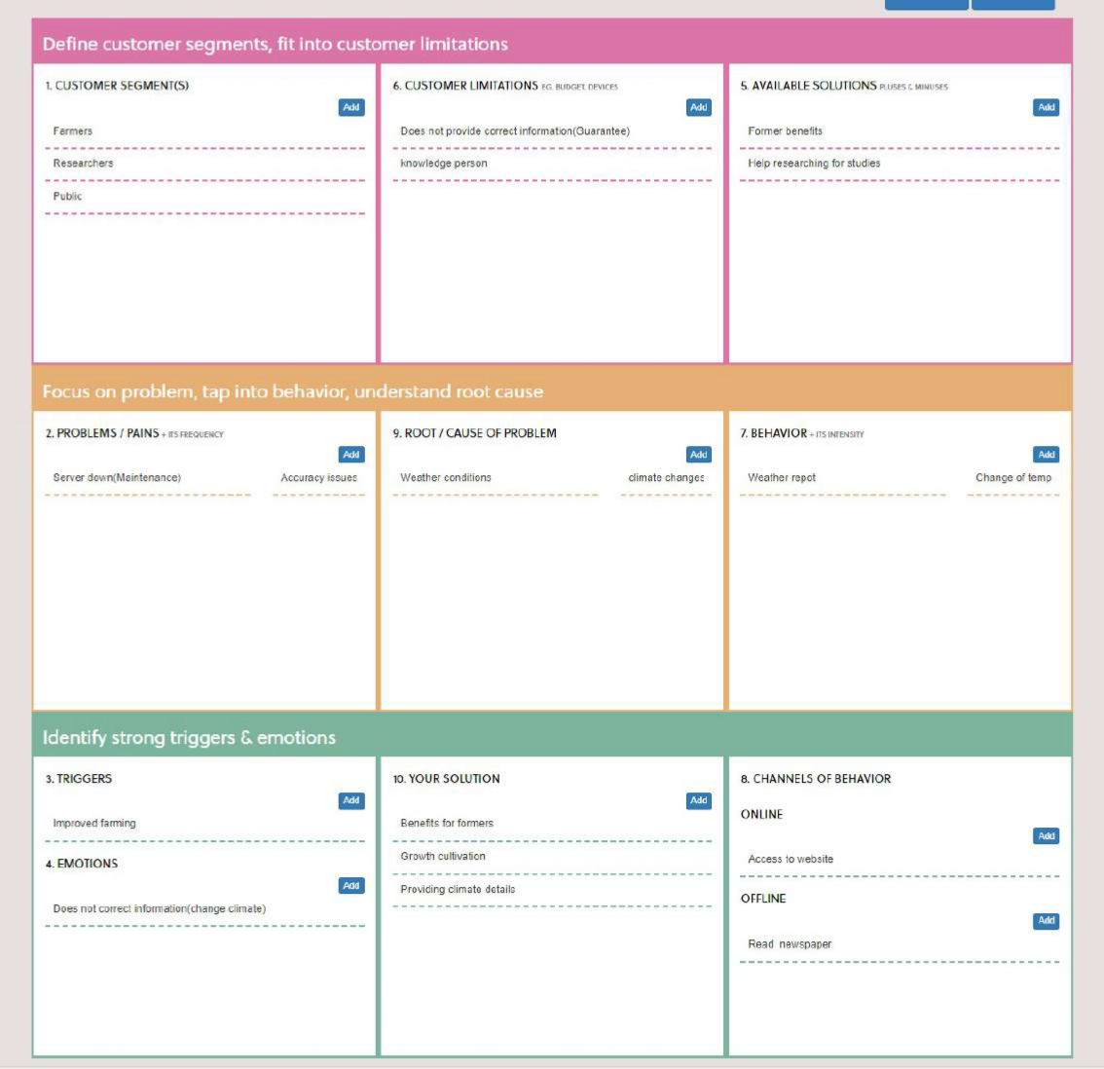
Template:

